Michael Knight

Task 4

Started off writing the code as instructed: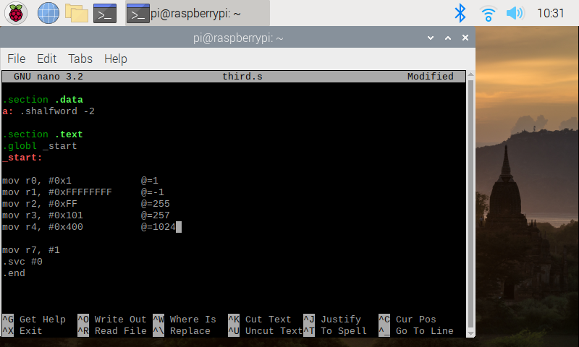

Got an error message that the complier didn’t understand “.shalfword” and this is because it should be “.hword” instead.

Then compiled and ran dbug

At each step I checked the registers as well

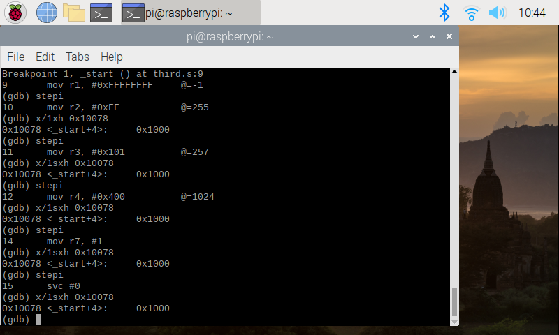

**Part2:**

Instructed to write the program Arithmetic3.s:

This is it in debug mode: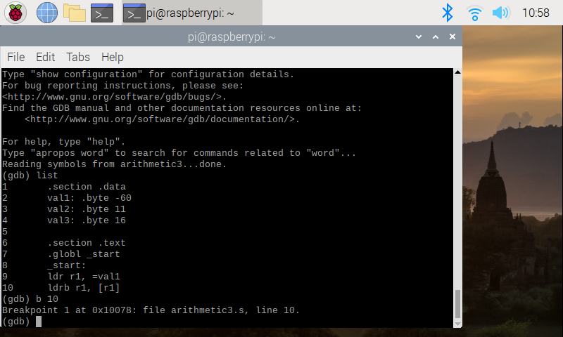

And this is the result of the registers after its ran